

**Compliance Report GUI Part**

# ***for***

**Food Delivery Service Management System**

***Authors :***

***Anish Sofat (19CS10011)***

***Satvik Bansal (19CS10053)***

***Aryan Agarwal (19CS30009)***

***Instructors : Prof. Sourangshu Bhattacharya***

***Prof. Abir Das***

***Uppada Vishnu***

**Indian Institute Of Technology Kharagpur**

**26 March 2021**

## 

## Customer

### Signup for customer

When clicked on the customer button on the page is redirected towards the personalised signup page

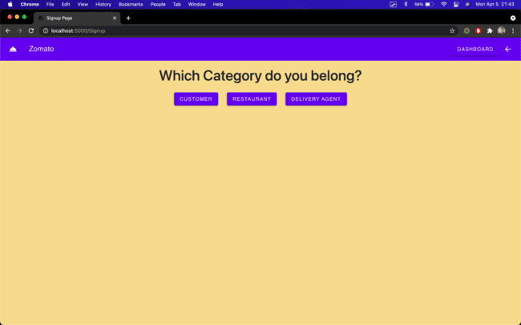

This is the redirected page

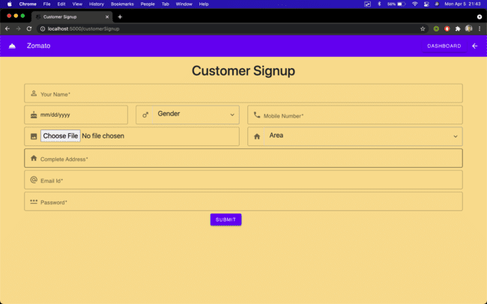

These are the dropdowns after clicking on the gender and area fields

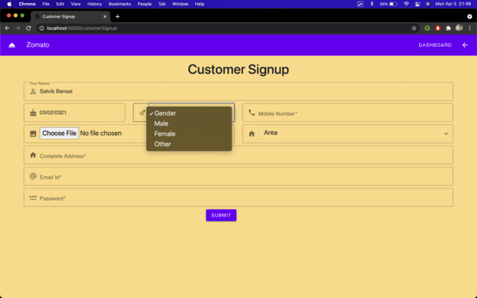

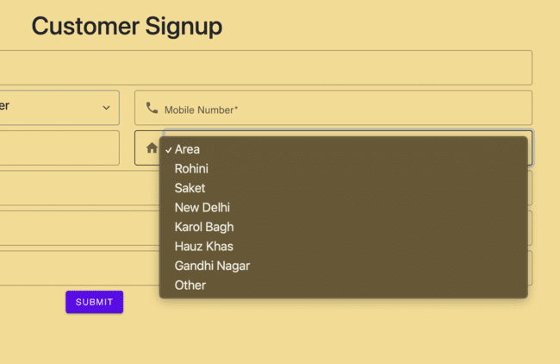

A dialogue box is opened when choose file is clicked for uploading an image

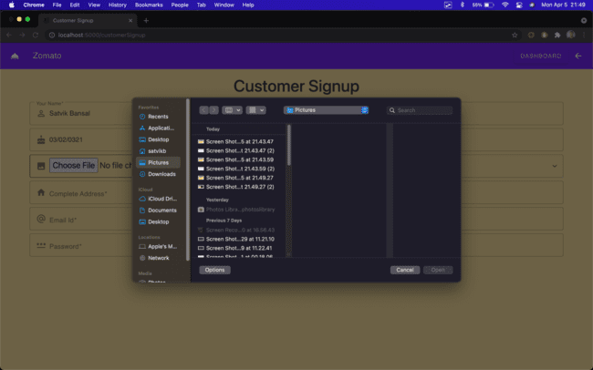

If any field is left empty, a popup on the field is shown and also changing the borders of the field to red.

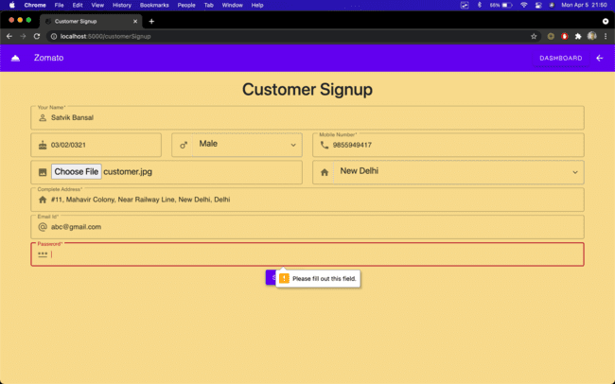

When filled completely the user should be redirected with a proper message on the page.

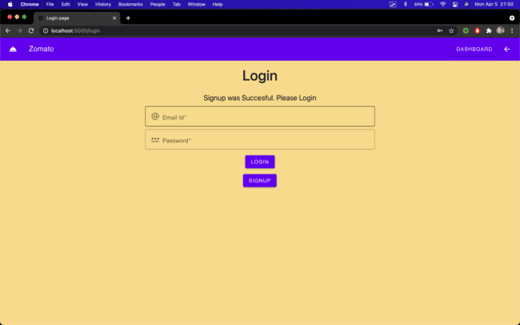

### Customer Login

While Logging in, if incorrect credentials or the fields are left empty, a suitable message is displayed

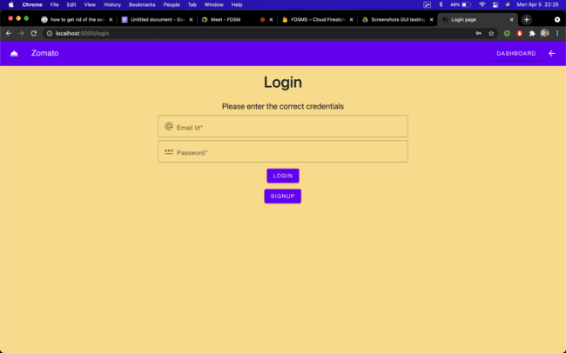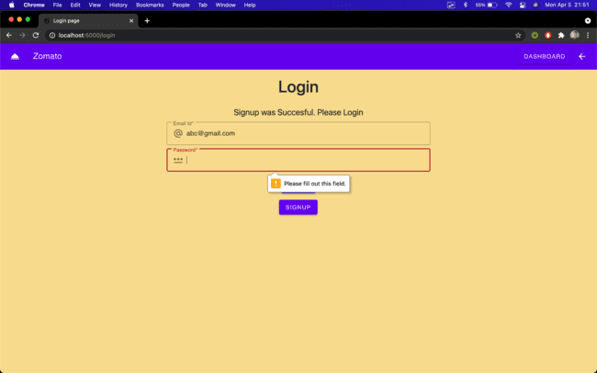

When the correct credentials are added, the user is redirected to the suitable dashboard.

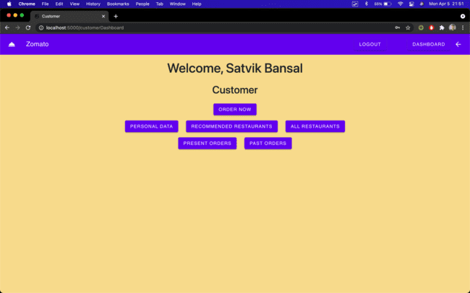

In the top banner, a logout button is shown, in order to log out from the session. The user should be redirected to the login page after logging out

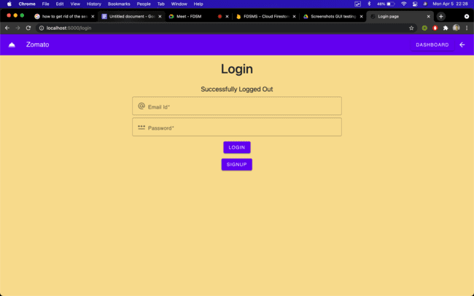

### Personal Data

When the personal data button is clicked, the user should be able to see a list of some of the details of themselves. The image is the one uploaded at the time of signup.

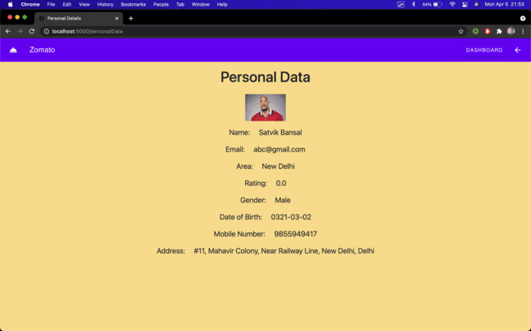

### 

### 

### 

### Order Now, View Menu

The buttons “Order Now”, “All Restaurants” redirects to the same page that should show the user of all the restaurants. The table will show some of the basic details about the restaurant. Recommended restaurants will also be shown in the list.

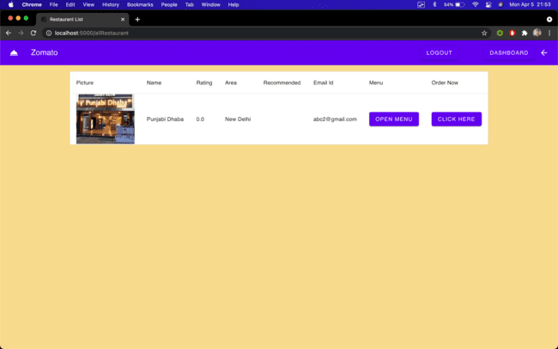

After clicking the “open menu”, or the “click here” button, the menu created by the restaurant should be shown.

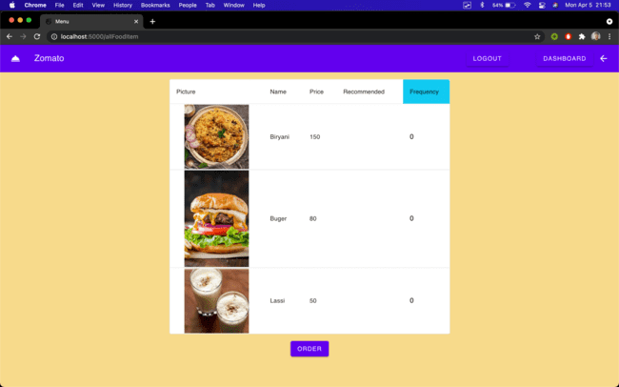

The table will show the image of the item, the name, price, recommended status and the quantity that needs to be ordered.

If the quantity is left at zero(or untouched) the item will not be shown in the order created.

After clicking the button “Order”, the order details should be shown.

Details of the offer selected should be there on the details.

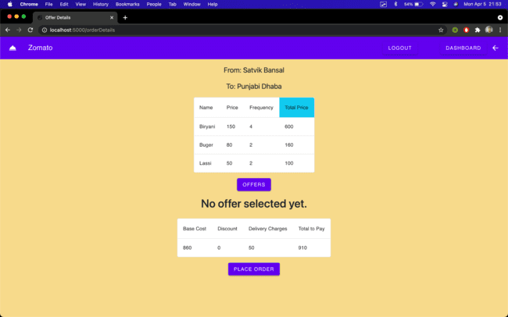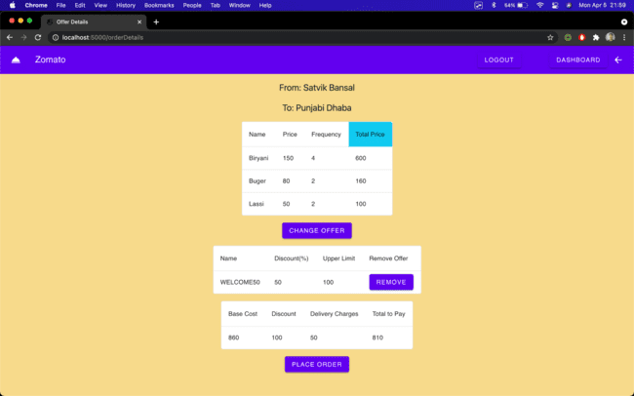

When the “Offers” button is clicked, the list of all the offers that are given to the customer by the admin should be visible, and removal should remove the offer from the order.

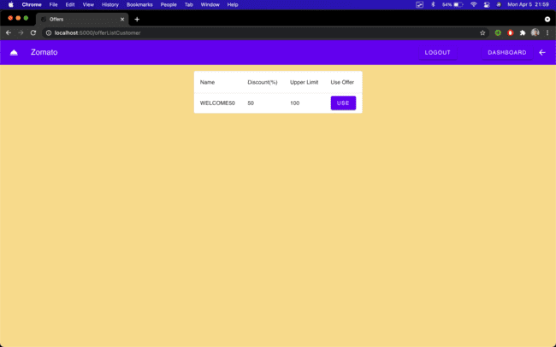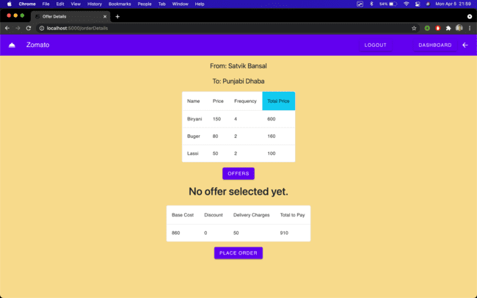

Placing the order should remove the offer, to prevent the use of the same offer in future.

The user should be redirected to the present Order page.

This page is also accessible by clicking the “Present Orders” Button on the dashboard.

### Present Order and Order Updates

This table will show some of the basic details of the order, with one short current status message.

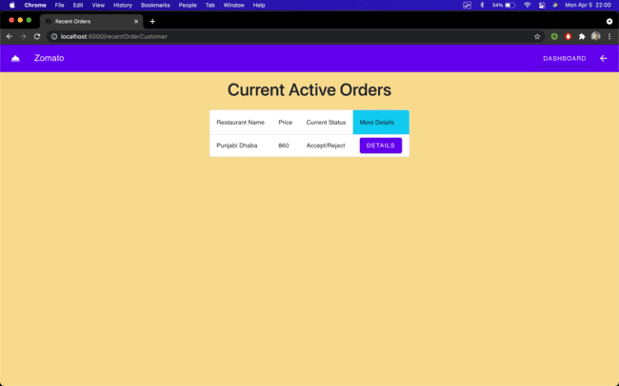

After clicking on the “Details” button, the user should be redirected to the details page of the order, which will show the details and timeline of the current order.

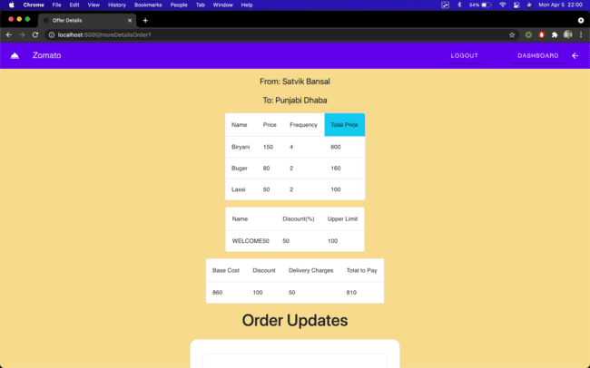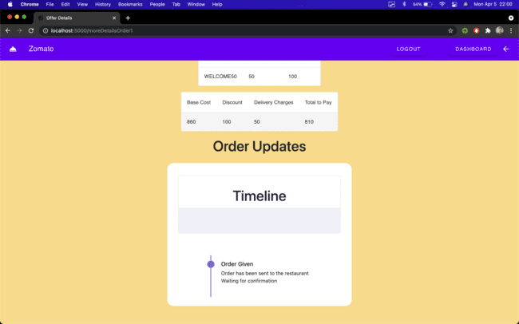

This timeline will be updated as the order updates are given by the restaurants and the delivery agents.

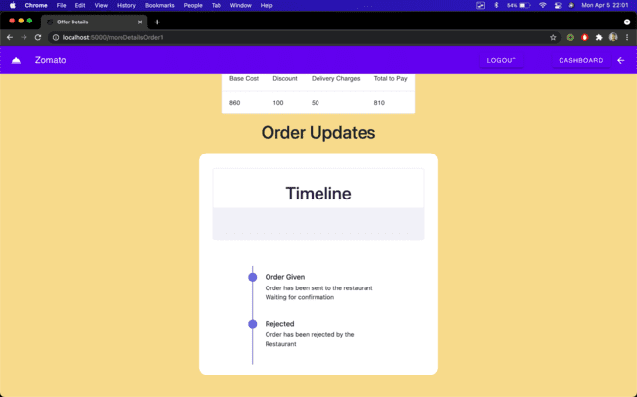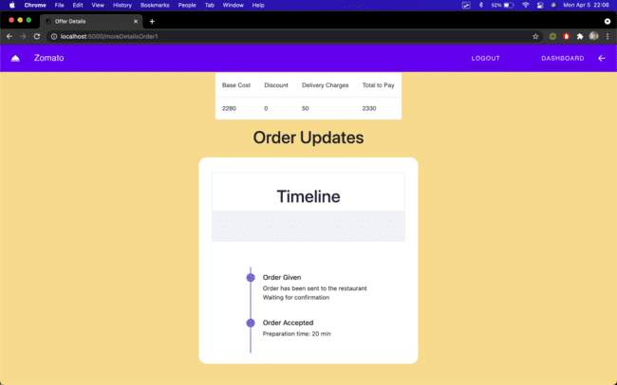

If the order is rejected the order should be moved to the past orders list, and if accepted the timeline should be shown respect.

When the food is prepared and the delivery request is sent by the restaurant, an appropriate update should be shown.

And when the request is accepted by the delivery agent, another update should be given, with the approximate time for the next update.

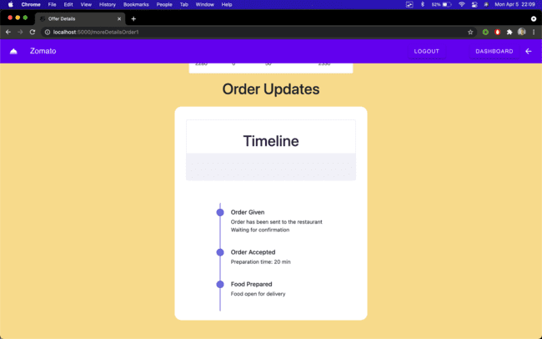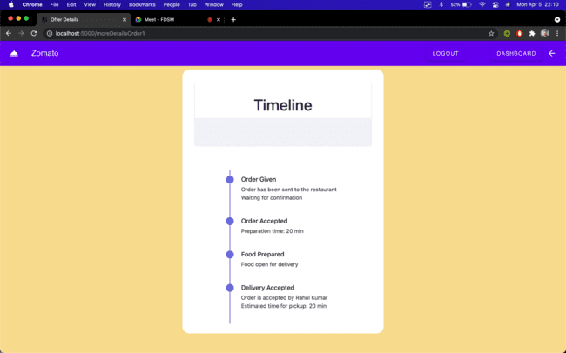

When the order is marked out for delivery, estimated time as given by the delivery agent should be shown.

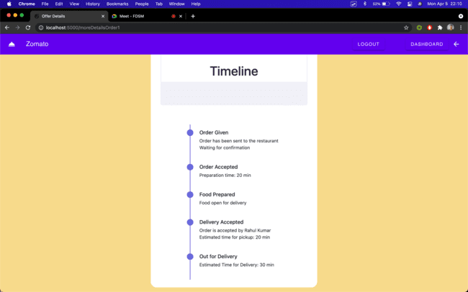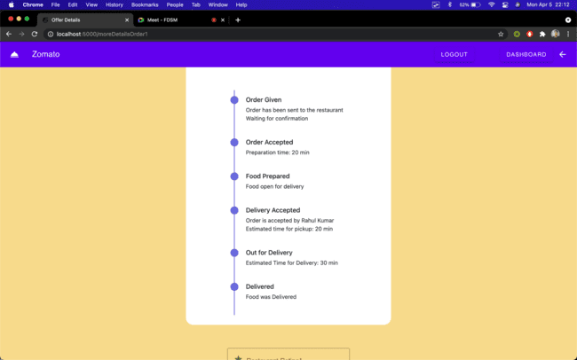

### 

### 

### Past Orders

At the same time when the order is delivered the order should be moved to the past order list of the customer.

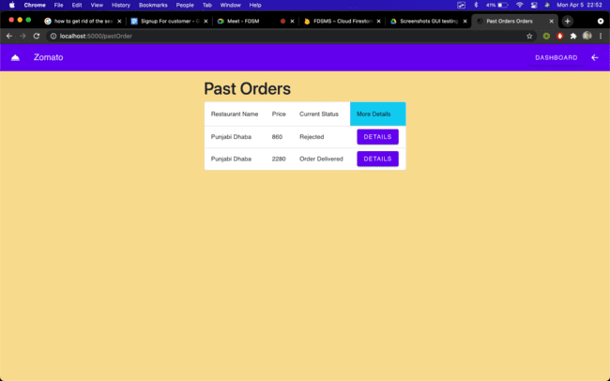

For the delivered orders, the customer should be able to provide the ratings for the restaurant and the delivery agent, which is allowed only once per order.

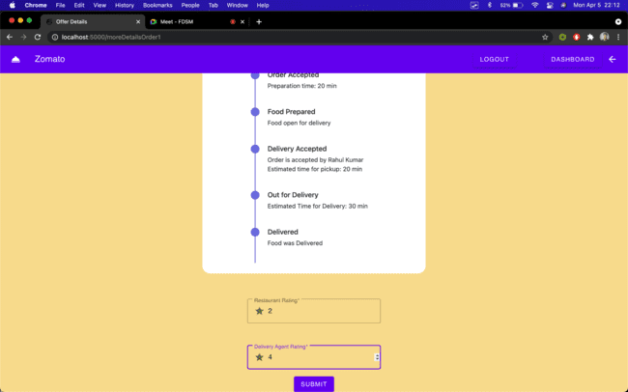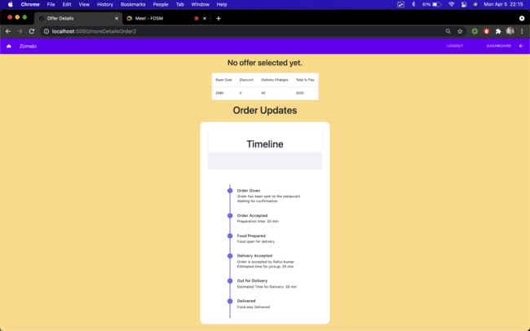

### 

### 

### 

### 

### Recommended Restaurants

There is a recommended restaurant list that shows all the recommended restaurant as done by the admin. Further functionalities are the same as that of all restaurant list.

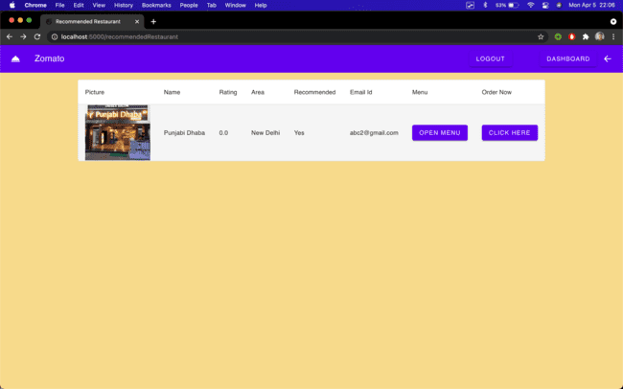

## 

## 

## 

## 

## 

## 

## 

## Restaurant

### Signup For Restaurant

When clicked on the restaurant button, the page is redirected towards the personalised signup page for restaurant



All Fields are mandatory and you cannot proceed without filling all of them up.

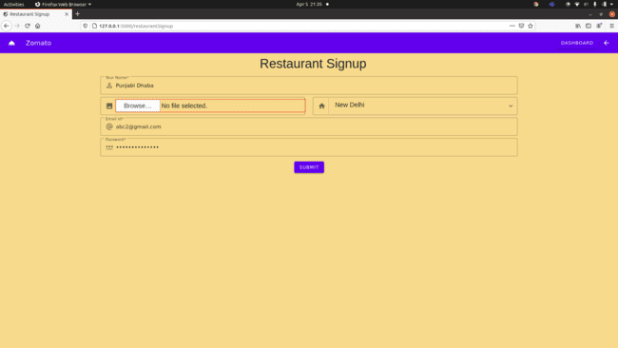

### Login

After Successful signup, redirection is done to the login page and a message appears on the top of the page which is as we had expected.

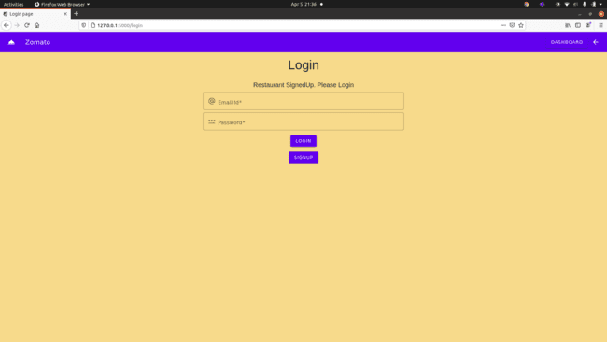

Login attempt with wrong password

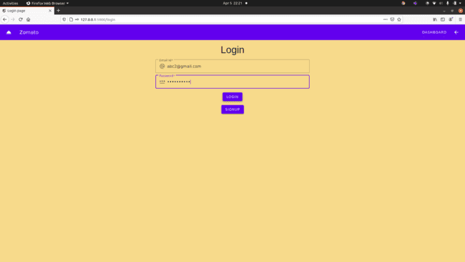

It given an error on validation of the email-id and password and displays a message on the top of the login page

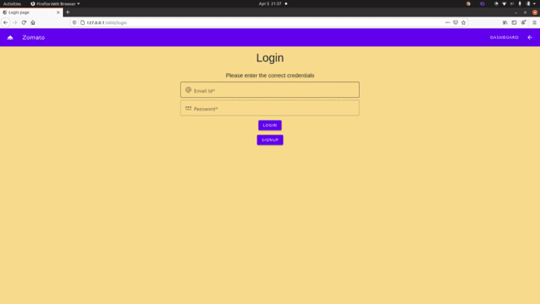

If you try to open dashboard without login it gives a message on the top and redirects back to the login page

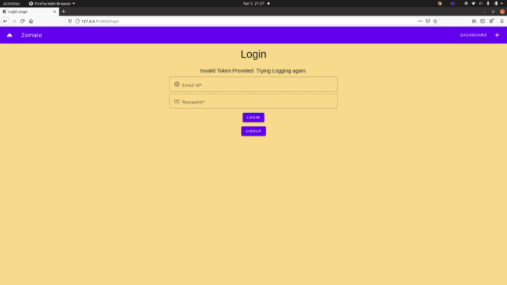

### Dashboard

A successful login redirects you to the restaurant dashboard.

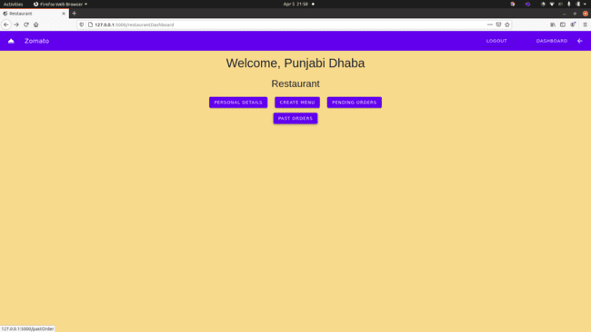

On clicking the personal details button redirection was properly done to the personal details html page and appropriate details were displayed.

### Personal Data

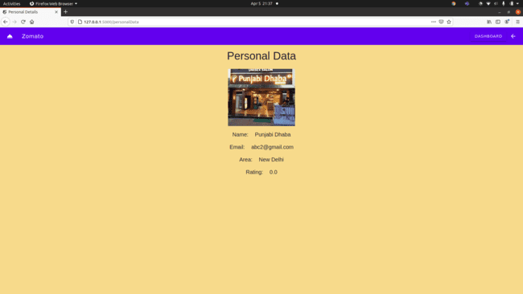

### Create Menu

On clicking the createMenu button from the dashboard, Initially there are no food items in the menu and the correct message was shown for the same.

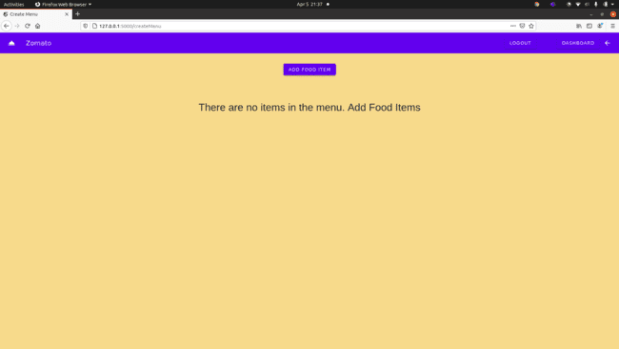

Add Food Item button on click redirects to a new page where a food item can be added using a form. All details are mandatory and cannot proceed before filling all details.

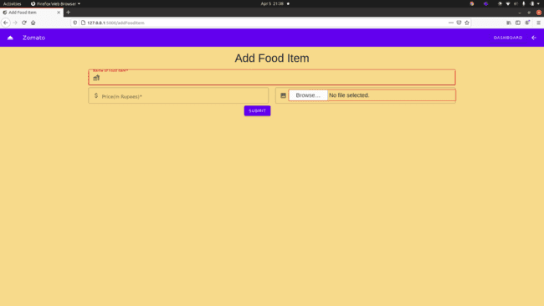

On successful insertion of food item it redirects to create menu html where 1 food item can be seen because of the new entry created.

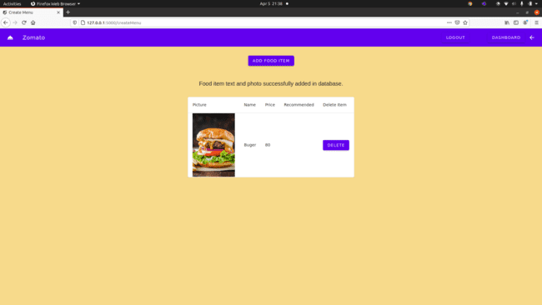

Similarly it was possible to create new food items.

2nd food item added.

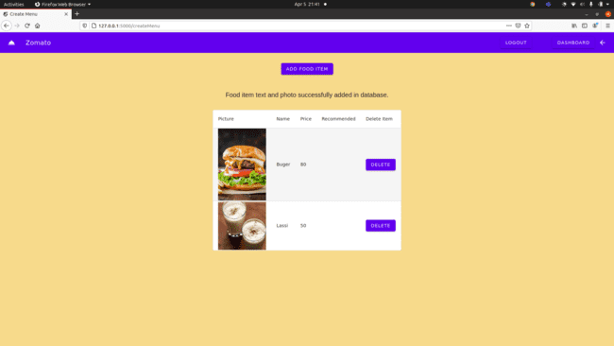

3rd food item added

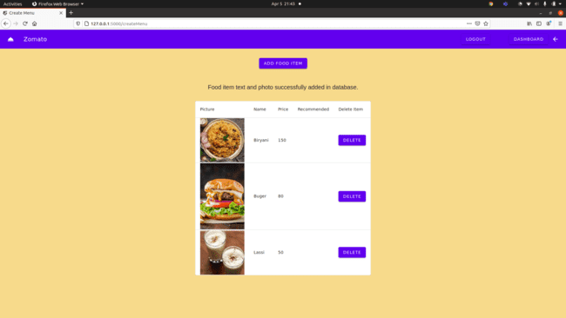

### Past/ Recent Orders

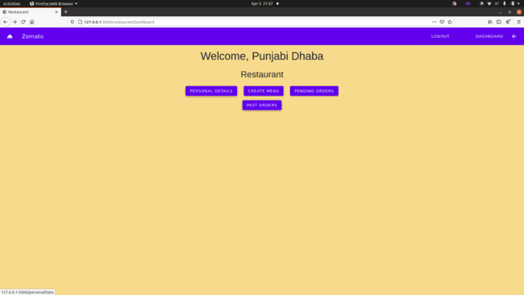

On clicking present orders, redirection was successfully done to a new page where no recent orders can seen be as customer has not given any order to the restaurant

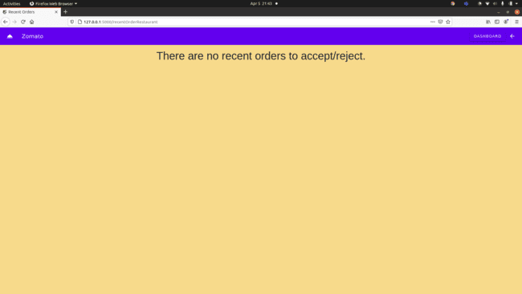

On clicking past orders, redirection was successfully done to a new page where no past order can be seen as no order has been completed yet.

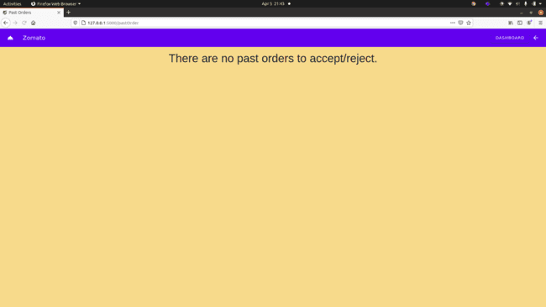

On clicking present orders, after the customer has given an order the restaurant was able to see the order.

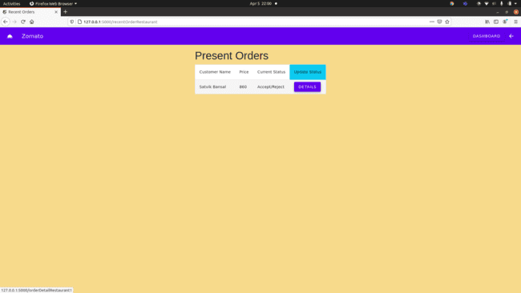

Restaurant was able to see the details of the order.

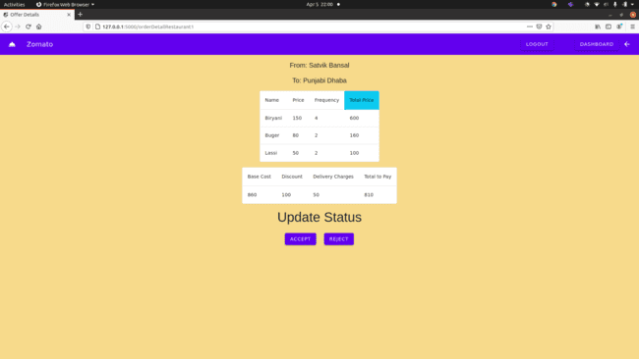

On rejection of the order, the order successfully moves to past order.

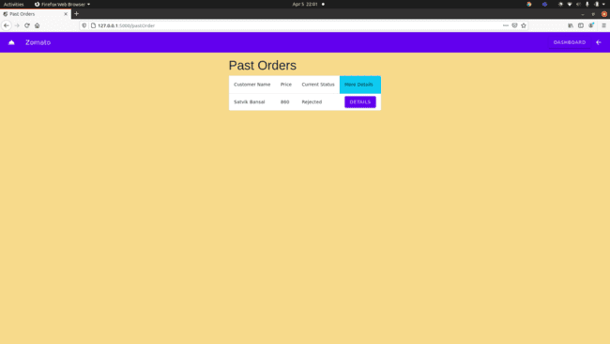

Restaurant was able to see the details of the past order.

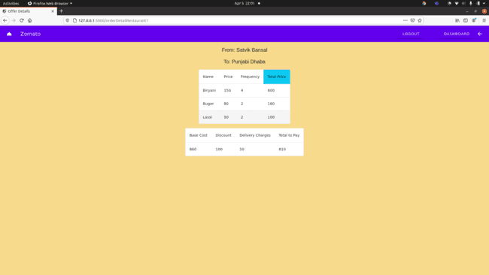

On clicking present orders, after the customer has given an order the restaurant was able to see the order.

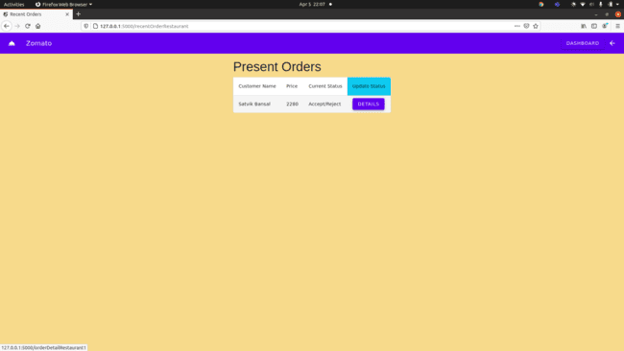

Restaurant was able to see the details of the order.

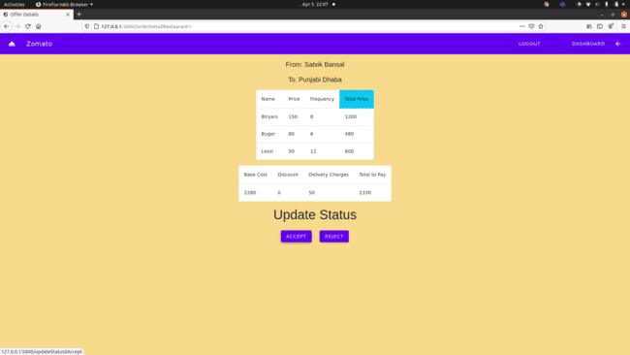

On acceptance of the order, the restaurant was mandated to give the estimated time.

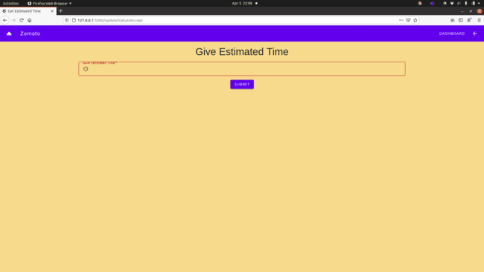

Restaurant gave a valid estimated time.

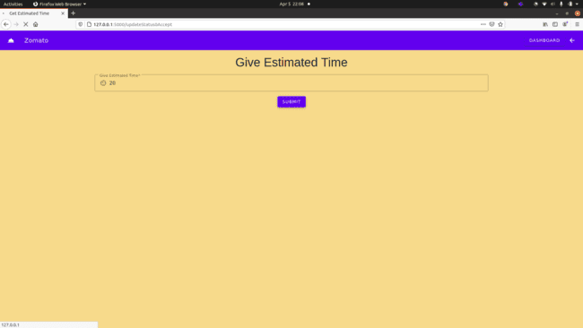

Present order current status was updated successfully.

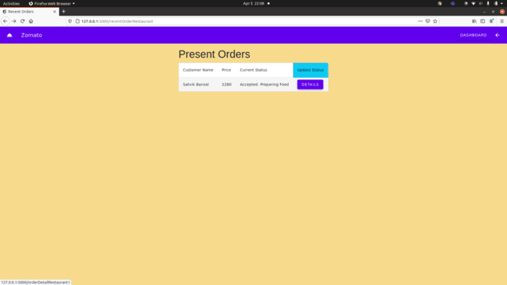

Restaurant was able to see the details of the order.

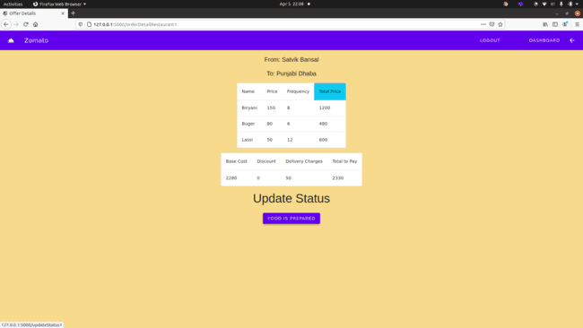

After food is prepared and restaurant can look for delivery agents.

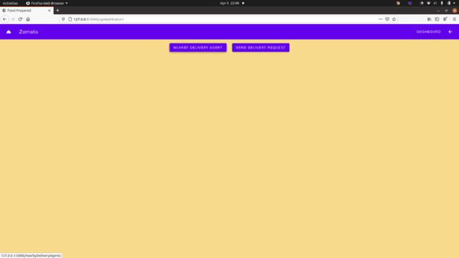

On clicking nearby delivery agent, it directs to a list of delivery agents in the area.

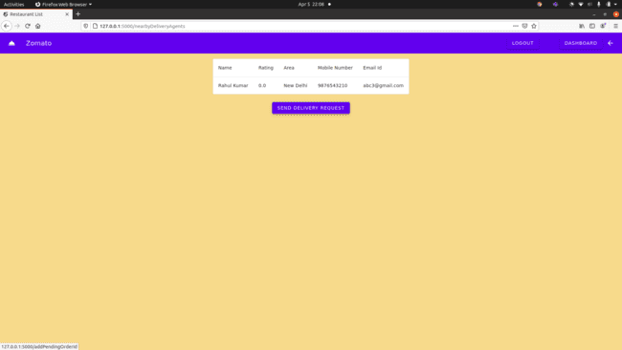

On clicking send delivery request a delivery request was sent to all the delivery agents in the area and present order current status was updated successfully.

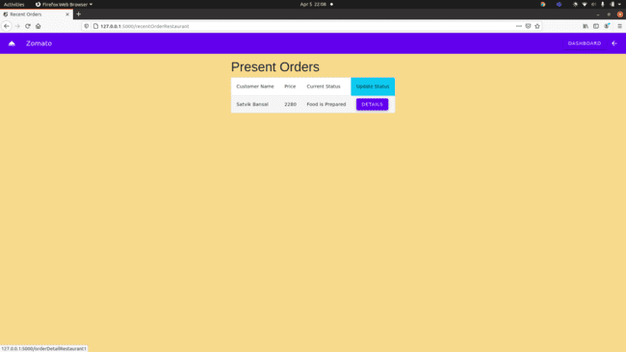

After a delivery agents accepts the order the current status of the present order current status updates successfully.

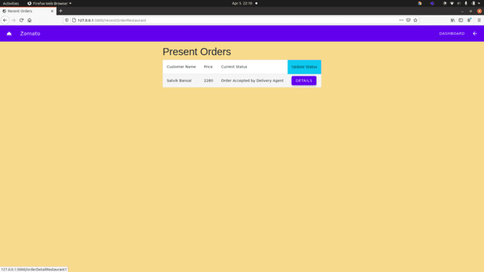

Restaurant was able to see the details of the order.

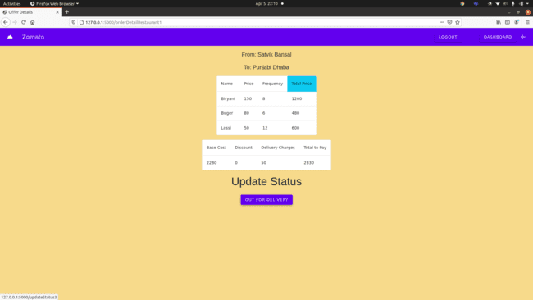

After delivery agent picks the order from the restaurant, the restaurant was able to update the current status of present order successfully.

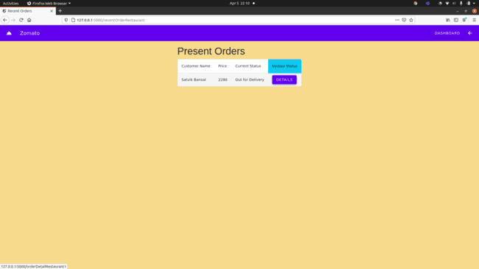

Restaurant was able to see the details of the order.

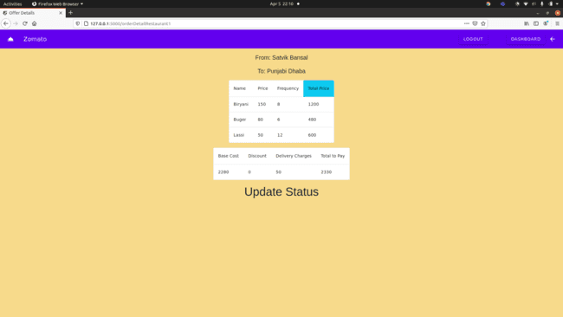

Past orders shows all the orders completed by the restaurant currently.

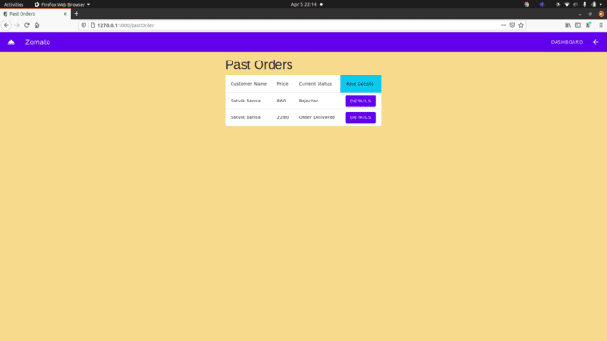

Restaurant was able to see the details of the past order.

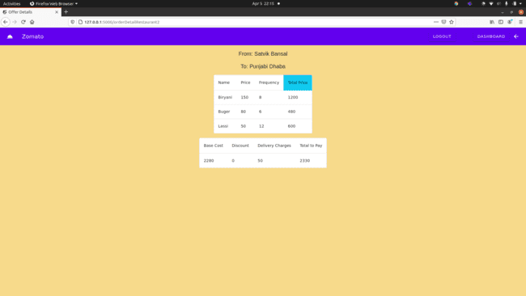

On clicking the logout button, the restaurant was able successfully logout.

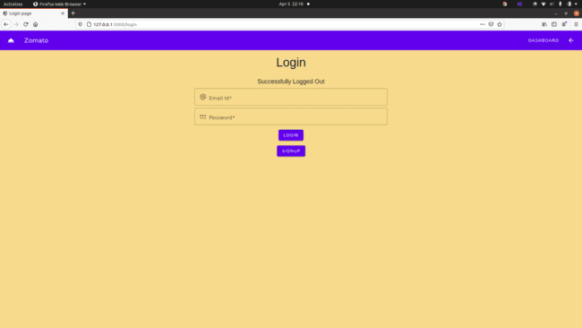

## Delivery Agent

### Signup for Delivery Agent

When clicked on the “delivery agent” button on the page is redirected towards the personalised signup page



This is the redirected page

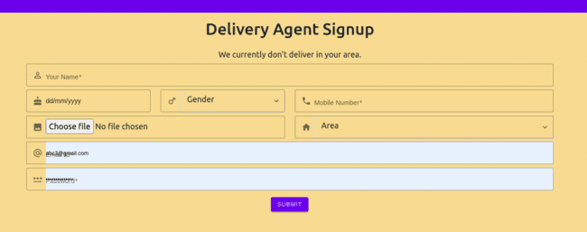

These are the dropdowns after clicking on the gender and area fields



A dialogue box is opened when choose file is clicked for uploading an image



If any field is left empty, a popup on the field is shown and also changing the borders of the field to red.

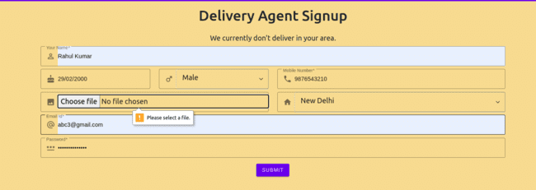

If the area “Other” is selected, then signup is to be prevented, and a proper message should be shown.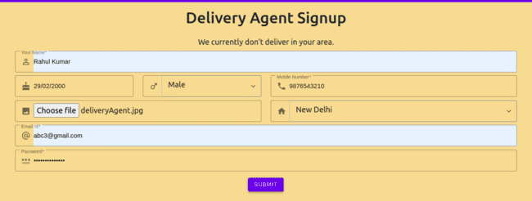

When filled completely the user should be redirected with a proper message on the page.

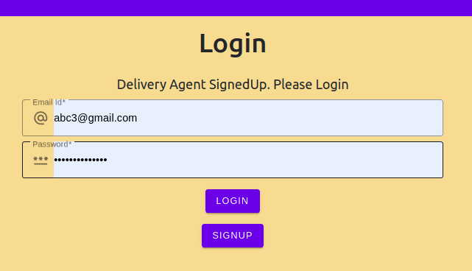

### Delivery Agent Login

While Logging in, if incorrect credentials or the fields are left empty, a suitable message is displayed



When the correct credentials are added, the user is redirected to the suitable dashoard

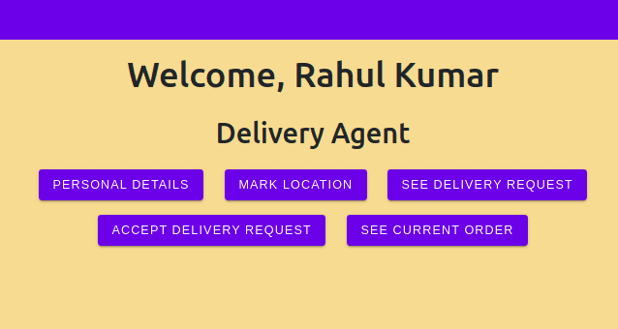

In the top banner, a logout button is shown, in order to log out from the session. The user should be redirected to the login page after logging out



### Personal Data

When the personal data button is clicked, the user should be able to see a list of some of the details of themselves. The image is the one uploaded at the time of signup.

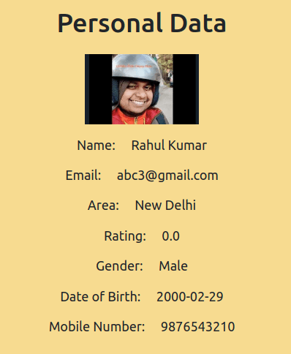

### Update Area

When the user clicks on the Mark Location Button, they should be redirected to a page showing the list of the areas and should be able to choose the new area. The change in the area should be visible in the personal details.

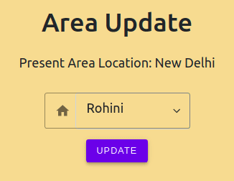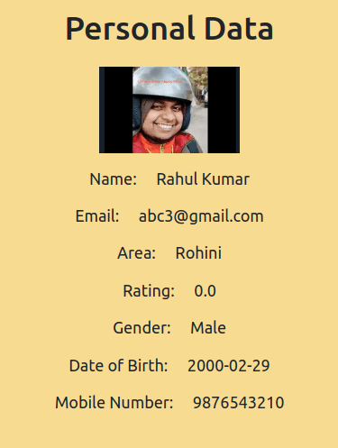

### Delivery Requests

If there is no delivery request, a proper message should be shown on the screen, otherwise, the list of the requests should be shown.

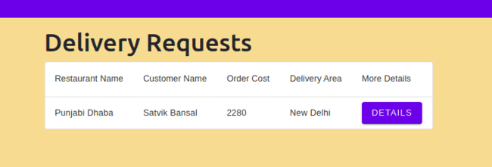

### Order Updates

When an order is accepted it should be shown in the “See Current Order” from the dashboard, and suitable buttons should be there for the update.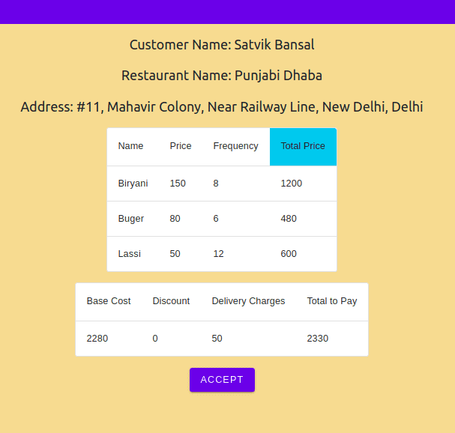

When an order is accepted, the approximate time for reaching the restaurant and the delivery time.

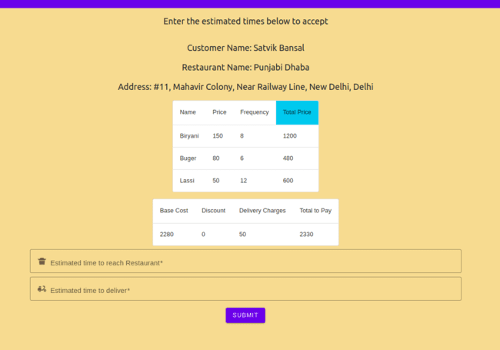

When the current order button is clicked, if there is no current order, a suitable message should be shown.

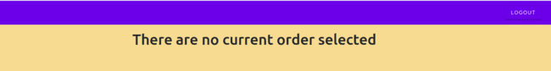

### Marking the order delivered

When the order is marked out for delivery, then the delivery agent should be allowed to mark the order delivered

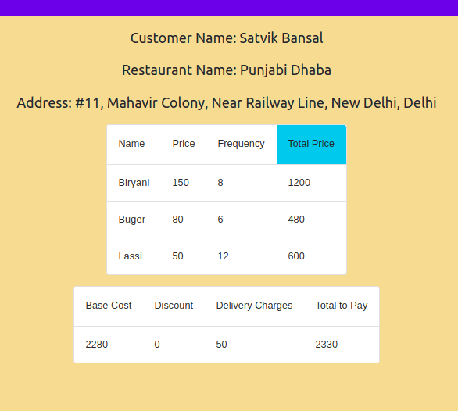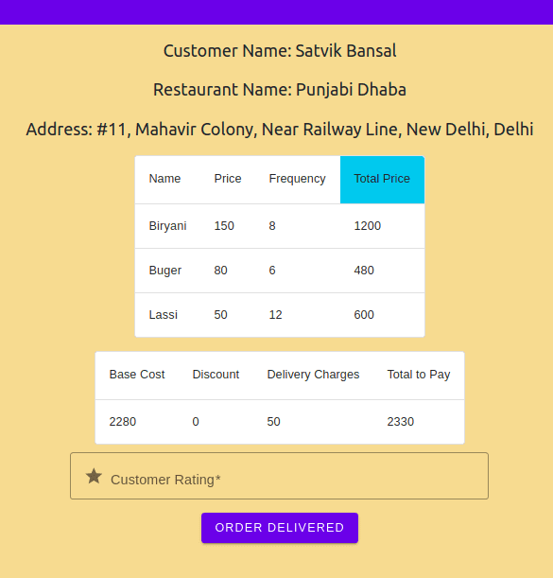

While marking the order delivered, giving the rating to the customer is necessary

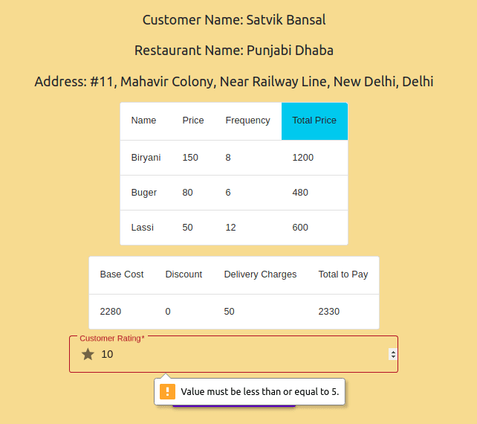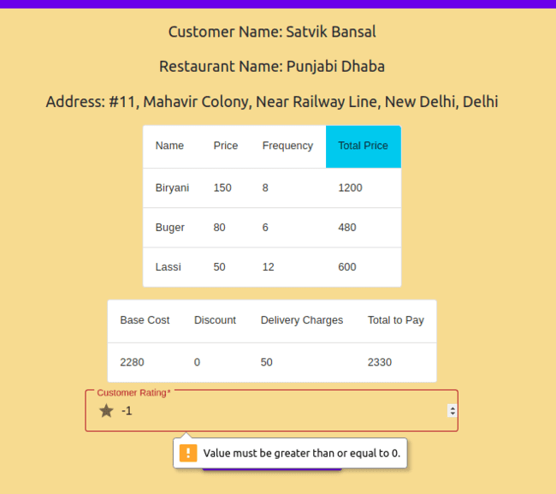

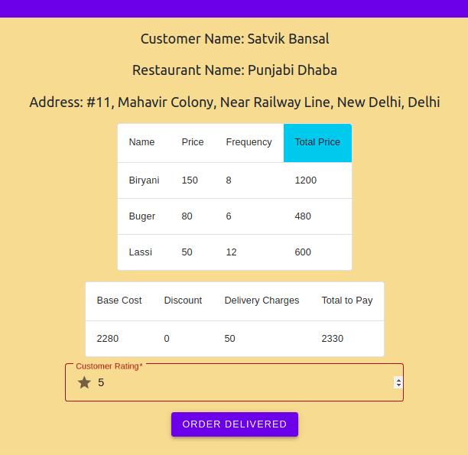

After marking the order as delivered, then the user should be redirected towards the dashboard.

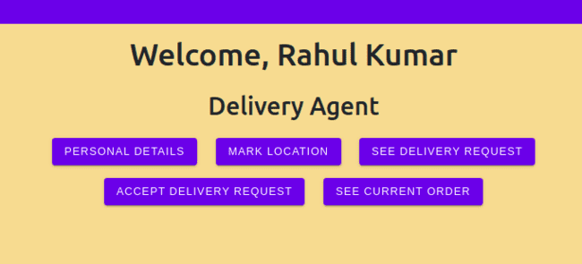

## Admin

### All customers/ Offer

All customers list

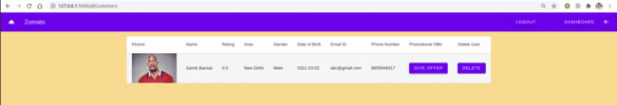

Clicked Give Offer for the customer, but there were no offers available in the offer list. So we first add an offer to the offer list.

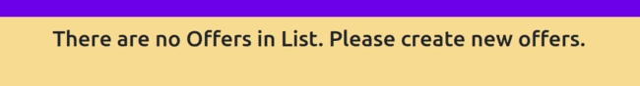

Button for adding new offers and list for showing already created offers.

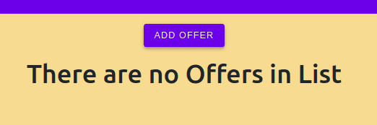

Create an offer by providing the required data.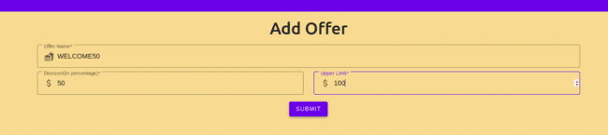

Now the offer will be added in the offer list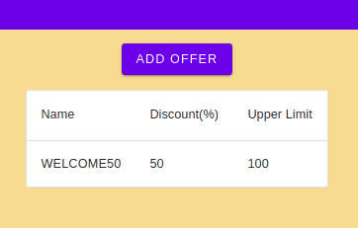

Now we will go to all customer list and give the created offer to the customer

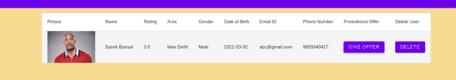

Click Give Offer to give the offer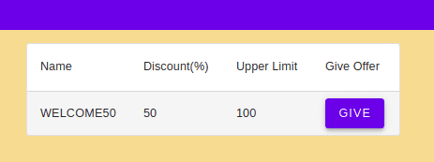

Now the offer is added to the customer

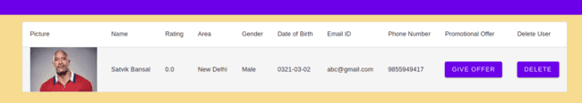

### All Restaurants/ Recommendations

See all restaurants (currently the first restaurant is not recommended)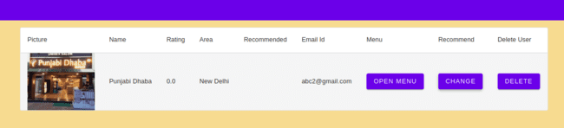

Recommend the first restaurant

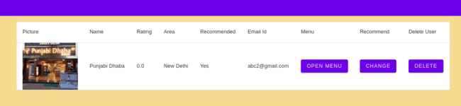Open menu for the first restaurant (currently none of it is recommended)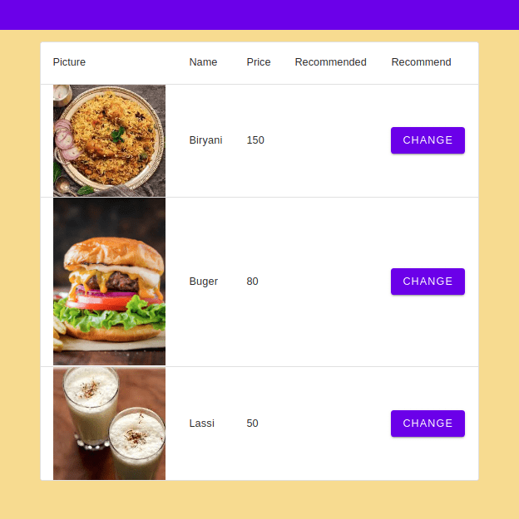

Recommend the food item “Burger”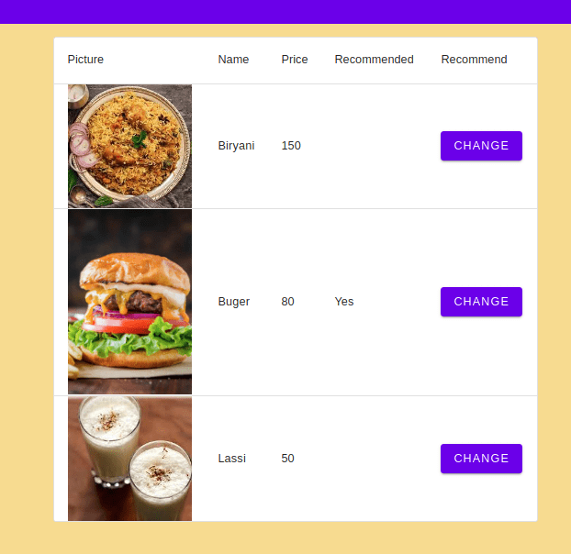

### Delivery Agent

See all delivery agents

